# SELF METER READING

#### Your Meter

# HOW TO READ YOUR METER

# Check the kind of meter available in your premises from the pictures below and read instructions on how you can read your meter

*Ignore the small digits marked by the red lines*

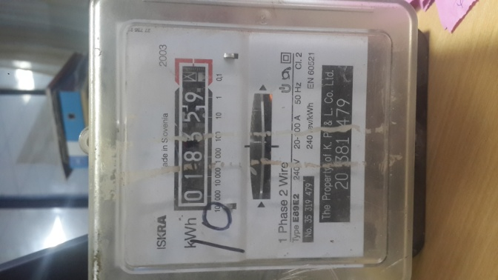

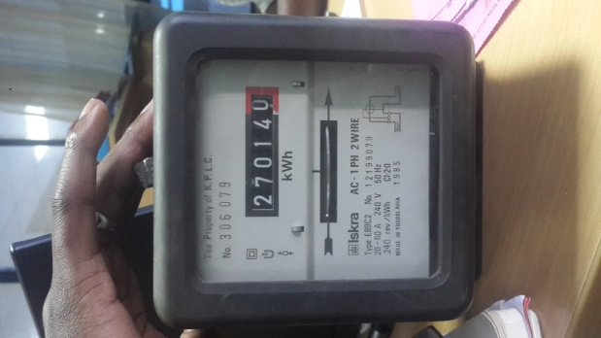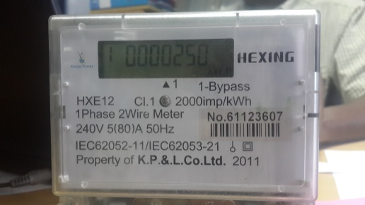

For any further information - Call 0703-070-707 or 0732-170-170



*Depending on the make of your meter – read only the white digits,*

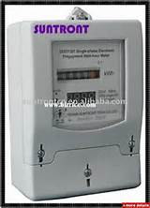

# You will have an opportunity to submit your readings - where you may not be available when the meter readers come to read your meter safely.

# You will learn more on your electricity consumption and be able to manage your power expenditure.

# REGISTRATION

We will register you using your

* Account Number
* Mobile Number

OR

Go to Kenya Power Website and

* Register as an I-Open Reader https://contactcentre.kplc.co.ke/KEIOPEN
* Open I-Open and Register as a self-reader

You will need to ensure that you submit your meter readings 3 days from the message notification date.

**NOTE :-** For every month that your meter is not read, we must estimate your power by using your last 12 months’ electricity consumption. .

# BE A SELF-READER

We are giving you the opportunity to read your own meter. You have been selected to participate in the 1st pilot Phase and will now be able to manage your bill by signing up as a Self-Reader

BENEFITS

The Benefits of submitting your own meter readings are:-

* Your monthly bill will be accurate as it will be an actual reading.

Yacht

An SMS will be sent to you once you have registered giving you the dates that you will need to send your reading and where to send the reading

For any further information - Call 0703-070-707 or 0732-170-170

[www.kenyapower.co.ke](http://www.kenyapower.co.ke)

Sailboat

#### SELF READER